An
INTERNSHIP REPORT
on

ServiceNow System Administrator
Submitted in partial fulfillment of the requirements for the award of the degree of
BACHELOR OF TECHNOLOGY
IN
COMPUTER SCIENCE AND ENGINEERING
by
RAGHURAMAN SANJANA
(Roll No. 23AK1A05H4)

Under the mentorship of
Mrs.N. Anitha, M.Tech,
Assistant Professor, CSE Department


DEPARTMENT OF COMPUTER SCIENCE AND ENGINEERING

ANNAMACHARYA INSTITUTE OF TECHNOLOGY AND SCIENCES, TIRUPATI

(AUTONOMOUS)
Approved by AICTE, New Delhi & Permanent Affiliation to JNTUA, Anantapuramu.
Five B .Tech Programmes (CSE, ECE, EEE, CE, ME) are accredited by NBA, New Delhi.
Accredited by NAAC with 'A' Grade, Bangalore. Accredited by Institution of Engineer(India)KOLKATA.
A-grade awarded by AP Knowledge Mission. Recognized under sections 2(f) & 12(B) of UGC Act 1956.
Venkatapuram (V), Renigunta (M), Tirupati, Tirupati District, Andhra Pradesh – 517520.
2026-27

ANNAMACHARYA INSTITUTE OF TECHNOLOGY AND SCIENCES, TIRUPATI (AUTONOMOUS)
DEPARTMENT OF COMPUTER SCIENCE AND ENGINEERING

CERTIFICATE
This is to certify that Ms. RAGHURAMAN SANJANA (23AK1A05H4) has carried out Virtual Internship on “ServiceNow System Administrator” and submitted to the Department of COMPUTER SCIENCE AND ENGINEERING of Annamacharya Institute of Technology and Sciences, in partial fulfilment of the requirements for the award of the Degree of Bachelor of Technology in Computer Science and Engineering is meeting the Academic Regulations.

Signature of Internship Mentor Signature of HOD

DECLARATION
I am RAGHURAMAN SANJANA (23AK1A05H4), Studying Final year B.Tech in Computer Science and Engineering of Annamacharya Institute of Technology and Sciences, hereby declare that this Internship report titled “ServiceNow System Administrator” has been done by me. The Internship work carried out is original and has not been submitted to any other University or Institution for the award of any credits. I promise to meet all the mandatory requirements as specified by the Academic regulations.

PLACE:
DATE :

SIGNATURE

ACKNOWLEDGEMENT
The needs and deeds of a particular person are only satisfied with the support and endurance of many.
I would like to express my deepest appreciation for All India Council for Technical Education, AICTE New Delhi for their commitment to the betterment of technical education and the opportunities they have made available to our students. I look forward to the continued collaboration between SMARTBRIDGE and APSCHE to provide more student Internships to gain hands-on experience and become better-prepared professionals.
I would like to extend my heartfelt thanks to Principal Dr. C. Nadhamuni Reddy for his constant encouragement and support during the Internship period.
I would like to express my heartfelt thanks to Dr. T. Sreenivasula Reddy, HOD, Professor, Department of CSE during the progress of Internship for his timely suggestions and help in spite of his busy schedule.
I would like to extend my heartfelt thanks to our department Internship Coordinator Mr. M Kiran Moni, Assistant Professor, Department of CSE for providing consistent support for us to complete the course modules in order to complete my internship.
My heartfelt thanks to Internship mentor Mrs. N. Anitha, Assistant Professor, Department of CSE
for his valuable guidance and suggestions in analysis and testing throughout the period, till the end of Internship work completion.
Finally, I would like to express my sincere thanks to faculty members of CSE Department, Lab
Technicians, Internship company trainers and friends, one and all that have helped me to complete the Internship successful .

RAGHURAMAN SANJANA
Roll No 23AK1A05H4


CERTIFICATE

ABSTRACT
The increasing need for effective service management has created significant opportunities to develop automated systems that can monitor Service Level Agreements (SLAs), improve accountability, and support timely corrective actions. This internship report presents the learning and practical experience gained through a Short-Term Virtual Internship Program of 2 months (120 hours) on ServiceNow, organized by SmartBridge Educational Services Pvt. Ltd. in collaboration with the Andhra Pradesh State Council of Higher Education (APSCHE). The internship provided an opportunity to understand the fundamental concepts, methodologies, and practical applications of ServiceNow through the development of a Zero-Code, Admin-Level SLA Governance Solution. The project focused on proactive SLA breach awareness, automated SLA risk detection, assignee notifications, mandatory breach justification, UI Policies, Virtual Agent guidance, role-based access control, real-time reporting, and executive dashboard visibility. Through the project, the learner developed an understanding of how ServiceNow can combine automation, conversational interfaces, and governance controls to monitor SLA performance, improve accountability, and support audit readiness. The internship experience helped strengthen technical knowledge, analytical thinking, problem-solving abilities, and practical understanding of ServiceNow administration and SLA governance. It also provided valuable industry-oriented exposure and helped bridge the gap between theoretical concepts learned in academics and their practical implementation in service management and governance.
Keywords: ServiceNow, SLA Governance, Service Level Agreement, SLA Breach Awareness, Virtual Agent, UI Policies, Role-Based Access Control, Service Management.

CONTENTS
Page No.
- Chapter 1 ……………………………………………………….….……………… 1
Introduction
- Chapter 2 ………………………………………..……………….……………….. 3
Weekly Overview
- Chapter 3 ……………………………………….………………………………… 4
Modules
- Chapter 4 .…………………………………….……………………………..…… 13
Project
- Chapter 5 .………………………………………………………………………... 41
Result and Conclusions
- Chapter 6 .………………………………………………………………………... 49
Verifiable Credentials

S.No. | Name of Figure | PageNo.
5.1 | SLA Governance Overview | 42
5.2 | SLA Virtual Agent | 42
5.3 | Incidents and SLA Register | 43
5.4 | SLA Breach Justification Module | 44
5.5 | SLA Governance Dashboard | 42

CHAPTER-1
INTRODUCTION
CHAPTER-1
INTRODUCTION
Service Level Agreements (SLAs) are an important part of modern IT service management, as they define the expected time and quality standards for delivering services and resolving incidents. Effective SLA management helps organizations monitor service performance, maintain accountability, and ensure that incidents are resolved within the agreed time limits. However, manually monitoring SLA deadlines can be difficult, especially when organizations handle a large number of incidents and service requests. Delayed identification of SLA risks may result in service breaches, reduced customer satisfaction, and difficulties in maintaining proper accountability and audit records.
ServiceNow is a widely used cloud-based platform for IT Service Management (ITSM) that provides tools for managing incidents, service requests, workflows, SLAs, users, and organizational processes. It enables organizations to automate routine activities and establish structured governance mechanisms without requiring extensive custom programming. SLA management in ServiceNow allows organizations to define service targets, track response and resolution times, and monitor the progress of incidents against established service commitments. By combining automation, access controls, notifications, and reporting capabilities, ServiceNow can provide a systematic approach to improving SLA compliance.
The effective governance of SLAs requires more than simply displaying whether an SLA has been breached. Organizations need proactive identification of SLA risks, timely communication with responsible users, mandatory documentation of breach reasons, and appropriate access restrictions. Automated workflows can identify incidents that are approaching their SLA limits and notify the respective assignees so that corrective action can be taken at the appropriate time. User interface policies and mandatory fields can further ensure that required information, such as breach justification, is captured consistently for accountability and audit purposes.
Conversational interfaces can also improve the usability of governance processes by providing users with an interactive method of receiving guidance and taking appropriate actions. ServiceNow Virtual Agent can support this requirement by providing a conversational layer through which users can be guided regarding SLA risks, acknowledgements, and corrective actions. Role-based access controls can restrict sensitive updates to authorized users, thereby reducing the possibility of unauthorized changes. Reports and dashboards can provide real-time visibility into SLA performance, breach trends, responsible assignees, and overall service compliance.
The practical implementation of this project involves configuring ServiceNow features such as SLA definitions, automated workflows, notifications, UI Policies, role-based access controls, Virtual Agent, reports, and executive dashboards. These components work together to create a structured SLA governance solution without requiring traditional programming. The project demonstrates how platform-based automation can be used to identify SLA risks, communicate important events, enforce governance requirements, and maintain appropriate records for organizational monitoring and auditing.
As part of the ServiceNow project, practical exposure was provided to the concepts and applications of IT Service Management, SLA management, workflow automation, governance, access control, conversational interfaces, and performance reporting. The project provided an opportunity to understand how ServiceNow can be configured to address practical organizational requirements and improve the management of service-level commitments. It also helped develop an understanding of how different platform capabilities can be integrated to create an effective and controlled service management process.
The project also provided an opportunity to strengthen important technical and professional skills, including workflow configuration, problem-solving, process analysis, access management, automation, reporting, and understanding of ITSM practices. The implementation helped demonstrate the importance of proactive monitoring, accountability, and standardized processes in maintaining service quality. It also provided practical experience in designing a solution that focuses on both operational efficiency and governance requirements.

CHAPTER-2
WEEKLY OVERVIEW

CHAPTER-2
WEEKLY OVERVIEW
Week 1
  Introduction to ServiceNow, ITSM, SLA Management, ServiceNow Applications and Requirement Analysis
Week 2
  SLA Definitions, Incident Management, SLA Configuration and SLA Monitoring
Week 3
  Workflow Automation, SLA Risk Detection, Notifications and UI Policies
Week 4
  SLA Governance, Breach Justification, Role-Based Access Control and Data Policies
Week 5
  Virtual Agent, Conversational Guidance, SLA Risk Acknowledgement and Corrective Actions
Week 6
  Reports, Performance Analytics, Executive Dashboard and SLA Trend Analysis
Week 7
  ServiceNow SLA Governance Project, Testing, Validation and Access Control Verification
Week 8
  Project Deployment, Documentation, Audit Readiness and Final Demonstration

CHAPTER-3
MODULES

CHAPTER-3
MODULES
The ServiceNow SLA Governance system is designed using a modular approach to ensure effective SLA monitoring, proactive breach awareness, accountability, security, and audit readiness. Each module performs a specific function and works with other modules to complete the overall SLA governance workflow. This structured approach follows service management principles such as process control, automation, role-based access, accountability, and centralized monitoring, allowing individual components to be configured or improved without affecting the complete solution.
The following sections describe the major modules involved in the ServiceNow SLA Governance system, including their purpose, technologies, responsibilities, and interactions.
SLA Management Module
Overview
The SLA Management Module is the core stage of the ServiceNow SLA governance workflow. It is responsible for defining, monitoring, and tracking Service Level Agreements associated with incidents and service activities. The module helps ensure that service commitments are continuously monitored and that potential SLA breaches are identified before they occur.
Core Features
• Defining SLA conditions and service targets.
• Tracking incident response and resolution times.
• Monitoring SLA progress and remaining time.
• Identifying incidents approaching SLA deadlines.
• Detecting SLA risks and potential breaches.

Technology Stack
• ServiceNow Platform
• ServiceNow ITSM
• SLA Definitions
• Incident Management
• ServiceNow Tables and Records
The configured SLA information is passed to the automation module for proactive monitoring and notification.
SLA Monitoring and Risk Detection Module
Purpose
The SLA Monitoring Module continuously monitors active SLA records and identifies incidents that are approaching their defined SLA limits.
SLA risk detection helps responsible users take corrective action before an actual breach occurs.
Key Responsibilities
• SLA Risk Detection: Identifying incidents approaching their SLA deadline.
• Time Monitoring: Tracking remaining response or resolution time.
• Breach Identification: Detecting SLA records that have reached or exceeded their target time.
• Status Monitoring: Monitoring the current state of incidents and SLA records.
• Risk Awareness: Providing early visibility into potential SLA breaches.

This module ensures that SLA risks are identified proactively rather than only after a breach has occurred.
Workflow Automation Module
Purpose
The Workflow Automation Module automates important SLA governance activities within ServiceNow. It reduces the need for manual monitoring and ensures that predefined actions are performed consistently when specific SLA conditions are satisfied.
Technology Stack
• ServiceNow Flow Designer
• ServiceNow Workflows
• Business Rules and Conditions
• SLA Records
• Incident Management
Key Responsibilities
• Creating automated SLA monitoring workflows.
• Triggering actions when SLA risk conditions are satisfied.
• Sending notifications to responsible assignees.
• Supporting escalation and corrective actions.
• Automating governance-related processes.
• Reducing manual SLA monitoring activities.

The automation module connects SLA monitoring with notifications and governance controls to provide a proactive SLA management process.
Notification and Alert Module
Purpose
The Notification Module provides timely communication to users when an SLA is approaching its limit or requires corrective action. Notifications improve SLA awareness and help responsible users respond before service commitments are breached.
Key Responsibilities
• Sending SLA risk notifications.
• Alerting assigned users about approaching deadlines.
• Communicating SLA breach information.
• Supporting timely corrective action.
• Providing clear information about SLA status.
• Improving accountability through timely communication.
Notifications are automatically generated based on the conditions configured within the SLA governance workflow.
SLA Breach Governance Module
Purpose
The SLA Breach Governance Module ensures that SLA breaches are properly documented and justified. It introduces mandatory governance controls so that users provide appropriate information when an SLA breach occurs. It captures the breach reason, supporting details, and other required information for proper review. This improves accountability, maintains accurate records, and helps prevent repeated SLA violations.
Key Responsibilities
• Enforcing mandatory breach justification.
• Capturing reasons for SLA breaches.
• Ensuring required information is entered by users.
• Supporting accountability for SLA performance.
• Maintaining information required for audit purposes.
• Standardizing the breach documentation process.
The governance controls help organizations maintain consistent records and improve audit readiness.
UI Policy and Data Control Module
Purpose
The UI Policy Module controls how fields and information are presented and maintained within ServiceNow. It can make breach-related information mandatory when specific conditions are satisfied.
Technology Stack
• ServiceNow UI Policies
• Data Policies
• Incident Forms
• SLA-related Fields
Key Responsibilities
• Making breach justification fields mandatory.
• Controlling field visibility and behavior.
• Enforcing required data entry.
• Supporting consistent information capture.
• Preventing incomplete governance records.
These controls ensure that required SLA governance information is captured consistently within the ServiceNow platform.
Role-Based Access Control Module
Purpose
The Role-Based Access Control Module protects SLA governance information by ensuring that only authorized users can perform specific actions or modify sensitive information.
Key Responsibilities
• Defining appropriate user roles.
• Restricting unauthorized updates.
• Controlling access to SLA-related records.
• Protecting governance information.
• Supporting administrative control.
• Maintaining secure service management processes.
Role-based access ensures that SLA governance activities are performed only by users with the appropriate permissions.
Virtual Agent Module
Purpose
The Virtual Agent Module provides a conversational governance layer that helps users understand SLA risks and take appropriate corrective actions. It provides an interactive method for users to acknowledge SLA risks and receive guidance.
Technology Stack
• ServiceNow Virtual Agent
• Conversational Interfaces
• SLA Governance Information
• ServiceNow Knowledge and Records
Core Features
• Conversational SLA guidance.
• SLA risk acknowledgement.
• Guidance on corrective actions.
• User interaction through natural-language conversations.
• Support for SLA governance activities.
• Improved accessibility of governance information.
The Virtual Agent communicates with ServiceNow processes and provides users with conversational guidance related to SLA risk and corrective action.
Reports and Analytics Module
Purpose
The Reports and Analytics Module provides visibility into SLA performance, breach trends, accountability, and service-level compliance. It helps administrators and management understand the overall performance of SLA processes.
Key Responsibilities
• Creating SLA performance reports.
• Monitoring SLA breach trends.
• Identifying responsible assignees.
• Tracking SLA compliance.
• Analyzing performance information.
• Providing information for management review.
Reports provide structured information that can be used to monitor and improve SLA governance.
Executive Dashboard Module
Purpose
The Executive Dashboard provides a centralized view of important SLA governance information. It allows administrators and management to monitor SLA trends, performance, breaches, and accountability through real-time visual information.
Core Features
• SLA performance overview.
• SLA breach trends.
• At-risk SLA visibility.
• Assignee accountability.
• Compliance information.
• Real-time reporting and monitoring.
The dashboard combines important SLA information into a centralized view for effective decision-making and governance monitoring.
Testing and Quality Assurance Module
Purpose
Testing ensures that the ServiceNow SLA Governance solution functions correctly and that its automation, governance, access control, notifications, and reporting features operate as expected.
Testing Strategy
• SLA Configuration Testing: Verifies that SLA definitions and conditions work correctly.
• Workflow Testing: Ensures that automated workflows are triggered correctly.
• Notification Testing: Checks whether SLA alerts are delivered to the appropriate users.
• UI Policy Testing: Verifies that mandatory breach justification is enforced.
• Access Control Testing: Ensures that unauthorized users cannot perform restricted updates.
• Virtual Agent Testing: Checks whether conversational guidance works correctly.
• Dashboard Testing: Verifies that reports and dashboard information are displayed correctly.
• User Acceptance Testing: Checks whether the solution satisfies governance and usability requirements.
This systematic testing process helps ensure that the ServiceNow SLA Governance solution is reliable, secure, consistent, and ready for practical use.
Documentation and Reporting Module
Purpose
Documentation provides a detailed record of the ServiceNow SLA Governance project, including requirements, configuration, workflow design, governance controls, testing, results, and conclusions.
Documentation Includes
• Problem Statement
• Requirements
• SLA Configuration
• Incident Management
• Workflow Automation
• SLA Risk Detection
• Notifications
• UI Policies
• Breach Justification
• Role-Based Access Control
• Virtual Agent
• Reports and Dashboard
• Testing Results
• Deployment Process
• Future Scope
Proper documentation makes the project easier to understand, maintain, modify, demonstrate, and extend.
Interdependence of Modules and Future Enhancements
Although each module performs a specific function, all modules work together to form a complete ServiceNow SLA Governance system.
The overall workflow can be represented as:
SLA Definition → SLA Monitoring → Risk Detection → Automated Notification → Breach Governance → Virtual Agent Guidance → Reporting → Executive Dashboard
The modular approach also allows future improvements without requiring major changes to the complete solution. Possible future enhancements include:
• Advanced SLA Prediction: Introducing intelligent mechanisms to identify SLA risks at an earlier stage.
• Automated Escalation: Extending workflows to automatically escalate critical SLA risks.
• Advanced Conversational Support: Expanding Virtual Agent capabilities for additional SLA governance activities.
• Enhanced Analytics: Adding more detailed SLA performance and compliance analysis.
• Integration with Other Systems: Connecting SLA governance with additional enterprise service management systems.
• Real-Time Monitoring: Providing enhanced real-time visibility into SLA performance and risk.
• Advanced Audit Support: Improving governance records and audit-related reporting.
The modular architecture of the ServiceNow SLA Governance system ensures efficient configuration, easy maintenance, scalability, and future adaptability. By integrating SLA management, workflow automation, notifications, governance controls, access management, conversational interfaces, reporting, and dashboards, the system provides a structured approach for proactive SLA monitoring, accountability, compliance, and audit readi

CHAPTER-4
PROJECT

CHAPTER-4
PROJECT
Overview:
The ServiceNow SLA Governance project focuses on applying ServiceNow administration and automation features to solve real-world SLA management problems through proactive monitoring and governance. The project follows a systematic workflow involving SLA configuration, SLA monitoring, risk identification, automated notifications, breach governance, access control, Virtual Agent interaction, reporting, and dashboard development. ServiceNow administration tools and configuration features are used to develop an efficient and reliable SLA governance solution.
The project demonstrates how ServiceNow automation and governance controls can transform SLA data into meaningful operational insights and actions. By monitoring SLA records and their progress, the system can identify potential risks and breaches and use automated workflows to notify responsible users, enforce breach justification, and provide administrators with visibility into SLA performance.
Objectives
• To understand and implement the complete ServiceNow SLA governance workflow.
• To configure and monitor SLA records for effective governance.
• To identify SLA risks that may contribute to potential breaches.
• To implement and compare suitable ServiceNow automation and governance features.
• To configure workflows and evaluate SLA performance using appropriate indicators.
• To develop a user-friendly governance solution for interacting with SLA records.
• To demonstrate the practical application of ServiceNow features in improving SLA compliance.
System Architecture
The system follows a four-layer architecture:
- **Data Layer** – Contains incident, task, and SLA records required for monitoring, governance, and reporting.
- **Data Processing Layer** – Performs SLA monitoring, condition checking, risk identification, validation, and governance processing.
- **ServiceNow Automation Layer** – Performs SLA monitoring, workflow automation, notifications, governance enforcement, Virtual Agent interaction, and access control.
- **Application Layer** – Provides a user-friendly interface through which users and administrators can manage SLA information and obtain real-time governance insights.
Data Flow
SLA Record → SLA Monitoring → Risk Identification → Automated Notification → Breach Governance → User Action → Reporting → Executive Dashboard
Development Process
The project was developed through a systematic series of stages:
1. Problem Identification and Requirement Analysis
The first stage involved identifying the real-world problems related to SLA monitoring, potential SLA breaches, accountability, and governance. Functional and technical requirements were analyzed to determine the required SLA definitions, workflows, governance controls, user roles, reports, and expected outcomes.
2. SLA Configuration
Relevant SLA requirements were collected and examined. The SLA configuration was analyzed to understand the applicable records, target times, conditions, schedules, stages, and overall structure required for effective SLA monitoring and governance.
3. SLA Monitoring and Governance Processing
The configured SLA records were monitored and prepared for governance. This stage included:
• Monitoring active SLA records.
• Identifying SLA records approaching their target time.
• Configuring automated notifications.
• Enforcing mandatory breach justification.
• Applying role-based access restrictions.
• Maintaining SLA accountability and governance information.
4. SLA Risk Analysis
SLA monitoring was performed to identify records that were approaching their defined targets and potential breach conditions. ServiceNow automation and workflow features were used to understand SLA status, identify risk conditions, and provide timely awareness to responsible users.
5. Governance Implementation
Different ServiceNow governance features were implemented according to the requirements of the project. Suitable configurations were created to manage SLA risks, breach conditions, user actions, and accountability.
Examples of features include:
• SLA Definitions
• Flow Designer
• UI Policies
• Virtual Agent
• Role-Based Access Control
6. Testing and Evaluation
The configured SLA governance solution was tested using different SLA scenarios. Performance was evaluated using suitable indicators such as:
• SLA Risk Detection
• Notification Delivery
• Breach Justification
• Access Control
• Governance Compliance
The performance of different configurations and workflows was compared to identify the most suitable approach for effective SLA governance.
7. Application Development
The selected ServiceNow configurations were integrated into a user-friendly governance application. The application allows authorized users to view SLA information, respond to SLA risks, provide breach justification, and obtain guidance through the configured ServiceNow features.
8. Deployment
After successful testing, the ServiceNow SLA governance solution can be deployed within the ServiceNow environment, allowing authorized users and administrators to access SLA monitoring, governance controls, reports, and dashboards through the platform.
Key Features
• SLA Monitoring: Monitors active SLA records and tracks their current progress.
• SLA Risk Detection: Identifies SLA records approaching their defined target time.
• Automated Notifications: Notifies responsible users when an SLA risk condition is detected.
• Breach Governance: Ensures that SLA breaches are properly documented and justified.
• UI Policies: Enforces mandatory information and governance requirements.
• Virtual Agent: Provides conversational guidance for acknowledging SLA risks and taking corrective action.
• Role-Based Access: Prevents unauthorized users from modifying important SLA-related information.
• Reporting and Dashboard: Provides visibility into SLA trends, accountability, and overall performance.
• Scalability: The modular architecture allows additional workflows, governance controls, and reporting features to be incorporated in the future.
Challenges and Solutions Data Quality
Challenge: SLA records may contain incomplete, inconsistent, or outdated information that can affect monitoring and governance.
Solution: Validation rules and governance controls were applied to improve the quality and reliability of SLA-related information.
Feature Selection
Challenge: A large number of SLA conditions and governance requirements can increase system complexity.
Solution: SLA conditions and governance requirements were analyzed to identify the most relevant controls for effective SLA monitoring.
Model Selection
Challenge: Different ServiceNow configurations and workflows may produce different levels of governance effectiveness. Solution: Multiple workflows, policies, and automation configurations were tested and evaluated to identify the most appropriate approach.
Model Performance
Challenge: The initial SLA governance configuration may not provide the desired level of monitoring and accountability.
Solution: Workflow optimization, governance controls, automated notifications, and configuration improvements were used to improve SLA management.
Deployment
Challenge: Integrating SLA governance features into a usable ServiceNow application requires proper configuration and access management. Solution: The configured SLA solution was integrated with ServiceNow administration features and prepared for deployment.
Outcomes
The ServiceNow SLA Governance project successfully demonstrates the complete process of developing an SLA management solution, starting from SLA configuration and monitoring through risk identification, automated notification, breach governance, and reporting. The project provides practical understanding of how ServiceNow features can monitor SLA activities, identify potential risks, enforce accountability, and provide real-time governance information.
The project also helped strengthen practical skills in ServiceNow administration, SLA configuration, Flow Designer, UI Policies, Virtual Agent, role-based access control, reporting, dashboard development, and governance. The experience demonstrates how ServiceNow features can be transformed into a practical solution for improving SLA compliance and operational accountability.
Future Scope
The ServiceNow SLA Governance project can be enhanced in several ways:
• Advanced SLA Analytics: Implement advanced analytics to identify recurring SLA risks and performance patterns.
• Real-Time Monitoring: Incorporate real-time monitoring for continuous SLA risk and breach awareness.
• Automated Governance: Automate additional governance actions and corrective workflows.
• Cloud Integration: Integrate SLA governance with scalable cloud-based ServiceNow environments.
• Advanced Dashboards: Add interactive dashboards and advanced SLA visualization.
• Explainable Governance: Provide clear explanations for SLA risk conditions and governance actions.
• Continuous SLA Monitoring: Periodically review SLA performance and update governance configurations.
• Mobile Application: Extend the SLA governance solution to ServiceNow mobile platforms.
In conclusion, ServiceNow in developing intelligent and governed SLA management solutions. The combination of SLA monitoring, automated workflows, breach governance, access control, conversational interfaces, reporting, and dashboard development provides a strong foundation for improving SLA compliance, accountbility, audit readiness, and operational performance.

SOURCE CODE:
<!DOCTYPE html>
<html>
<head>
<title>SLA Breach Awareness System</title>
<style>
body {
font-family: Arial;
margin: 0;
background: #f4f7fb;
}
header {
background: #0f172a;
color: white;
padding: 20px;
}
nav button {
padding: 10px;
margin: 5px;
}.
.container {
padding: 25px;
}
.view {
display: none;
}
.view.active {
display: block;
}
.card {
background: white;
padding: 20px;
margin: 15px 0;
border-radius: 10px;
}
.grid {
display: grid;
grid-template-columns: repeat(4,1fr);
gap: 15px;
}
input, select, textarea {
padding: 10px;
margin: 5px;
}
button {
padding: 10px 15px;
cursor: pointer;
}
table {
width: 100%;
border-collapse: collapse;
background: white;
}
th, td {
padding: 10px;
border: 1px solid #ddd;
}
.progress {
background: #ddd;
height: 8px;
}
.progress span {
display: block;
height: 100%;
background: #2563eb;
}
</style>
</head>
<body>
<header>
<h2>Virtual Agent-Driven SLA Breach Awareness & Justification System</h2>

<nav>
<button onclick="showView('home')">Overview</button>
<button onclick="showView('chat')">Virtual Agent</button>
<button onclick="showView('incidents')">Incidents & SLA</button>
<button onclick="showView('breaches')">Justifications</button>
<button onclick="showView('dashboard')">Dashboard</button>
</nav>
</header>
<div class="container">
<!-- OVERVIEW -->
<section id="home" class="view active">
<div class="card">
<h2>Control SLA Risk Before It Becomes a Breach</h2>
<p>
This system monitors incidents, checks SLA progress,
identifies SLA risks, detects breaches and collects
mandatory breach justifications.
</p>
<button onclick="showView('chat')">
Open Virtual Agent
</button>
</div>
<div class="grid">
<div class="card">
<h3>Total Incidents</h3>
<h2 id="total">0</h2>
</div>
<div class="card">
<h3>Active Risks</h3>
<h2 id="risk">0</h2>
</div>
<div class="card">
<h3>Breached SLAs</h3>
<h2 id="breached">0</h2>
</div>
<div class="card">
<h3>Compliance</h3>
<h2 id="compliance">0%</h2>
</div>
</div>
<div class="card">
<h3>Main Features</h3>
<ul>
<li>Incident and SLA monitoring</li>
<li>75% SLA risk warning</li>
<li>SLA breach detection</li>
<li>Mandatory breach justification</li>
<li>Manager review status</li>
<li>Virtual Agent assistance</li>
<li>Dashboard reporting</li>
</ul>
</div>
</section
<!-- VIRTUAL AGENT -->
<section id="chat" class="view">
<div class="card">
<h2>SLA Governance Virtual Agent</h2>
<div id="messages"></div>
<input
id="chatInput"
placeholder="Ask about SLA..."
onkeydown="if(event.key==='Enter') sendMessage()"
>
<button onclick="sendMessage()">
Send
</button>
</div>
</section>
<!-- INCIDENTS -->
<section id="incidents" class="view">
<div class="card">
<h2>Incidents & SLA Monitoring</h2>
<button onclick="showForm()">
Add Incident
</button>

<div id="incidentForm" style="display:none">
<input id="description"
placeholder="Incident description">
<select id="priority">
<option value="1">P1 - Critical</option>
<option value="2">P2 - High</option>
<option value="3">P3 - Moderate</option>
</select>
<input
id="group"
placeholder="Assignment Group"
value="Service Desk">
<input
id="elapsed"
type="number"
placeholder="Hours Elapsed">
<button onclick="addIncident()">
Create Incident
</button>
</div>
</div>
<table>
<thead>
<tr>
<th>Incident</th>
<th>Description</th>
<th>Priority</th>
<th>Group</th>
<th>Progress</th>
<th>Status</th>
</tr>
</thead>
<tbody id="incidentTable">
</tbody>
</table>
</section>
<!-- JUSTIFICATIONS -->
<section id="breaches" class="view">
<div class="card">
<h2>SLA Breach Justification</h2>
<label>Incident</label>
<select id="justIncident"></select>
<br>
<label>Reason</label>
<select id="reason">
<option>Vendor Delay</option>
<option>Resource Unavailable</option>
<option>Technical Complexity</option>
<option>Customer Unavailable</option>
<option>Incorrect Assignment</option>
<option>Dependency</option>
<option>Major Outage</option>
<option>Other</option>
</select>
<br>
<textarea
id="explanation"
placeholder="Explain why the SLA was breached">
</textarea>
<br>
<button onclick="submitJustification()">
Submit Justification
</button>
</div>
<table>
<thead>
<tr>
<th>Incident</th>
<th>Reason</th>
<th>Explanation</th>
<th>Review</th>
</tr>
</thead>
<tbody id="justificationTable">
</tbody>
</table>
</section>
<!-- DASHBOARD -->
<section id="dashboard" class="view">
<div class="grid">
<div class="card">
<h3>Completed</h3>
<h2 id="completed">0</h2>
</div>
<div class="card">
<h3>At Risk</h3>
<h2 id="dashRisk">0</h2>
</div>
<div class="card">
<h3>Breached</h3>
<h2 id="dashBreached">0</h2>
</div>
<div class="card">
<h3>Justifications</h3>
<h2 id="justCount">0</h2>
</div>
</div>
<div class="card">
<h3>SLA Governance Process</h3>
<p>
Incident Created →
SLA Monitoring →
75% Warning →
SLA Breach →
Justification →
Manager Review
</p>
</div>
</section>
</div>
<script>
const SLA_HOURS = 4
let incidents = [
{
number: "INC0010001",
description: "Critical production application issue",
priority: 1,
group: "Application Support",
elapsed: 3.2
},
{
number: "INC0010002",
description: "Production database outage",
priority: 1,
group: "Database Team",
elapsed: 4.6
},
{
number: "INC0010003",
description: "Email notification issue",
priority: 2,
group: "Service Desk",
elapsed: 1.4
},
{
number: "INC0010004",
description: "Payment service degradation",
priority: 1,
group: "Application Support",
elapsed: 2.6
}
];
let justifications = [];
function showView(view) {
document.querySelectorAll(".view")
.forEach(section => {
section.classList.remove("active");
});
document.getElementById(view)
.classList.add("active");
renderAll();
}
function getStatus(incident) {
if (incident.priority != 1) {
return "Not Applicable";
}
let percentage =
(incident.elapsed / SLA_HOURS) * 100;
if (percentage >= 100) {
return "Breached";
}
if (percentage >= 75) {
return "At Risk";
}
return "Within SLA";
}
function renderIncidents() {
let table =
document.getElementById("incidentTable");
table.innerHTML = "";
incidents.forEach(incident => {
let percentage =
(incident.elapsed / SLA_HOURS) * 100;
let status =
getStatus(incident);
table.innerHTML += `
<tr>
<td>${incident.number}</td>
<td>${incident.description}</td>
<td>P${incident.priority}</td>
<td>${incident.group}</td>
<td>
<div class="progress">
<span style="width:${Math.min(percentage,100)}%"></span>
</div>
${Math.min(percentage,100).toFixed(0)}%
</td>
<td>${status}</td>
</tr>
`;
});
}
function renderJustifications() {
let table =
document.getElementById("justificationTable");

table.innerHTML = "";
justifications.forEach(item => {
table.innerHTML += `
<tr>
<td>${item.incident}</td>
<td>${item.reason}</td>
<td>${item.explanation}</td>
<td>Pending</td>
</tr>
`;
});
}
function updateDashboard() {
let risk = incidents.filter(
i => getStatus(i) === "At Risk"
).length;
let breached = incidents.filter(
i => getStatus(i) === "Breached"
).length;
let completed = incidents.filter(
i => getStatus(i) === "Within SLA"
).length;
document.getElementById("total").textContent =
incidents.length;
document.getElementById("risk").textContent =
risk;
document.getElementById("breached").textContent =
breached;.
document.getElementById("completed").textContent =
completed;
document.getElementById("dashRisk").textContent =
risk;
document.getElementById("dashBreached").textContent =
breached;
document.getElementById("justCount").textContent =
justifications.length;
let compliance =
incidents.length ?
((incidents.length - breached) /
incidents.length * 100) : 0;
document.getElementById("compliance").textContent =
compliance.toFixed(0) + "%";
}
function showForm() {
document.getElementById("incidentForm")
.style.display = "block";
}
function addIncident() {
let number =
"INC" + String(incidents.length + 10001);
let incident = {
number: number,
description:
document.getElementById("description").value,
priority:
Number(document.getElementById("priority").value),
group:
document.getElementById("group").value,
elapsed:
Number(document.getElementById("elapsed").value)
};
incidents.push(incident);
renderAll()
}
function submitJustification() {
let incident =
document.getElementById("justIncident").value;
let reason =
document.getElementById("reason").value;

let explanation =
document.getElementById("explanation").value;
if (!explanation) {
alert("Please provide an explanation.");
return;
}
justifications.push({
incident: incident,
reason: reason,
explanation: explanation
});
document.getElementById("explanation").value = "";
renderAll();
}
function sendMessage() {
let input =
document.getElementById("chatInput");
let question =
input.value.toLowerCase();
if (!question) return;
let answer =
"I can help you with SLA monitoring, risks, breaches and justifications.";
if (question.includes("breached")) {
let list =
incidents.filter(
i => getStatus(i) === "Breached"
);
answer =
"Breached incidents: " +
list.map(i => i.number).join(", ");
}
else if (question.includes("risk")) {
let list =
incidents.filter(
i => getStatus(i) === "At Risk"
);
answer =
"At-risk incidents: " +
list.map(i => i.number).join(", ");
}

else if (question.includes("justify")) {
answer =
"Select the breached incident, choose a breach reason and provide a detailed explanation.";
}
else if (question.includes("sla")) {
answer =
"SLA monitoring checks elapsed time against the 4-hour SLA. At 75% the incident becomes At Risk, and at 100% it becomes Breached.";
}
document.getElementById("messages")
.innerHTML +=
"<p><b>You:</b> " + input.value + "</p>";
document.getElementById("messages")
.innerHTML +=
"<p><b>Agent:</b> " + answer + "</p>";
input.value = "";
}
function renderAll() {
renderIncidents();
renderJustifications();
updateDashboard();
let select =
document.getElementById("justIncident");
select.innerHTML = "";
incidents
.filter(i => getStatus(i) === "Breached")
.forEach(i => {
select.innerHTML +=
`<option>${i.number}</option>`;
});
}
renderAll();
</script>
</body>
</html>

CHAPTER-5
RESULTS AND CONCLUSIONS

CHAPTER-5
RESULTS AND CONCLUSIONS
The SLA Governance project successfully demonstrates the practical application of ServiceNow-based automation and governance for monitoring and managing Service Level Agreements (SLAs). The system monitors incident information such as priority, assigned team, SLA progress, incident status, and breach conditions to identify incidents that are within SLA, at risk, or breached.
The project follows a complete SLA Governance workflow consisting of incident registration, SLA monitoring, at-risk identification, breach detection, breach justification, manager review, and dashboard-based reporting. The system provides an SLA Governance Virtual Agent, incident monitoring register, breach justification module, and governance dashboard to support service desk managers in tracking SLA performance and taking appropriate action.
5.0 Results
After configuring the SLA governance rules and monitoring the incident records, the system was able to identify at-risk and breached incidents, track SLA progress, record breach justifications, and provide a centralized dashboard for monitoring SLA compliance. The Virtual Agent also provided users with guidance related to SLA status, breaches, and governance procedures.
Figure 1: SLA Governance Overview
The SLA Governance Overview provides a high-level view of the complete SLA management environment. It presents key indicators such as total incidents, active SLA risks, breached SLAs, and overall compliance. The Attention Queue highlights incidents that require immediate attention, while the Governance Pulse displays important policy information such as the P1 SLA target, at-risk trigger, and number of open justifications. The interface provides quick access to the Virtual Agent and incident register, enabling users to monitor SLA performance, identify potential breaches, and take appropriate governance actions.

Figure 5.1: SLA Governance Overview
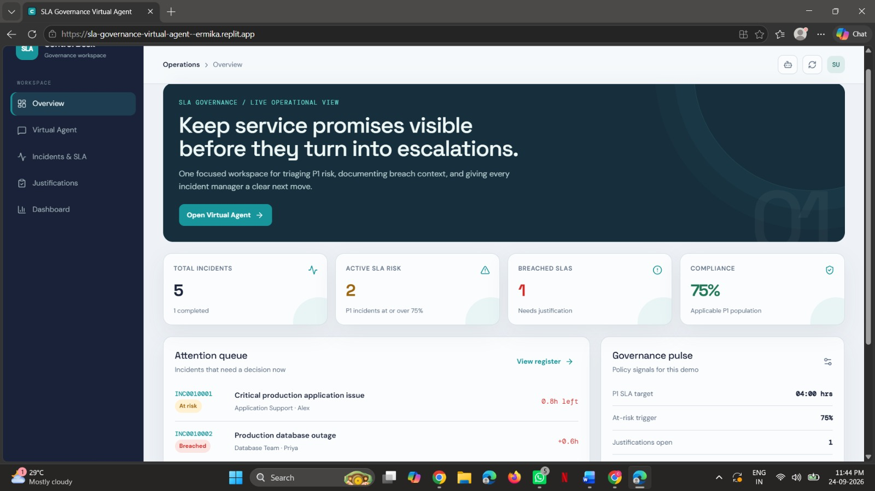

Figure 2: SLA Governance Virtual Agent
The SLA Governance Virtual Agent provides an interactive interface for users to obtain information about incidents and SLA status. It can provide guidance related to SLA risks, breaches, dashboard information, and the overall governance workflow. Quick actions are provided for frequently required operations such as checking an incident's SLA, listing breached or at-risk work, explaining the project workflow, and understanding how to justify a breach. The agent uses the available incident and justification information to provide relevant operational guidance to service desk managers.
Figure 5. 2: SLA Governance Dashboard
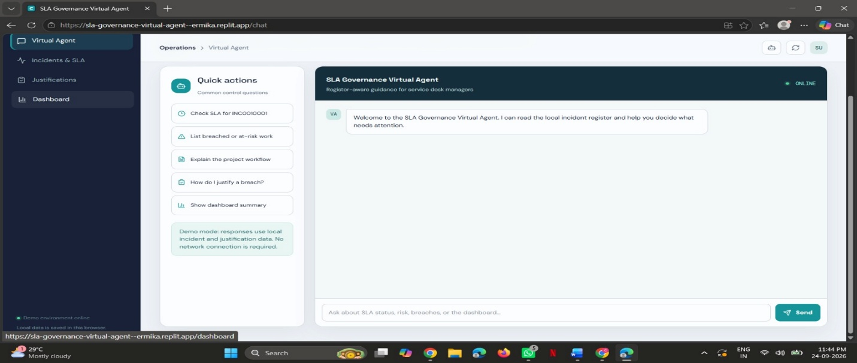

Figure 3: Incidents and SLA Register
The Incidents & SLA module provides a detailed operational register of all incidents and their corresponding SLA status. Each incident contains information such as incident ID, description, priority, assigned owner, SLA progress, and current status. The system identifies incidents as At Risk, Breached, Within SLA, Not Applicable, or Completed based on their SLA progress and priority. The module also provides options to resolve or reopen incidents and allows users to add new incidents. This helps service desk teams continuously monitor SLA performance and take appropriate action before or after a breach occurs.
Figure 5.3: Incidents and SLA Monitoring Register
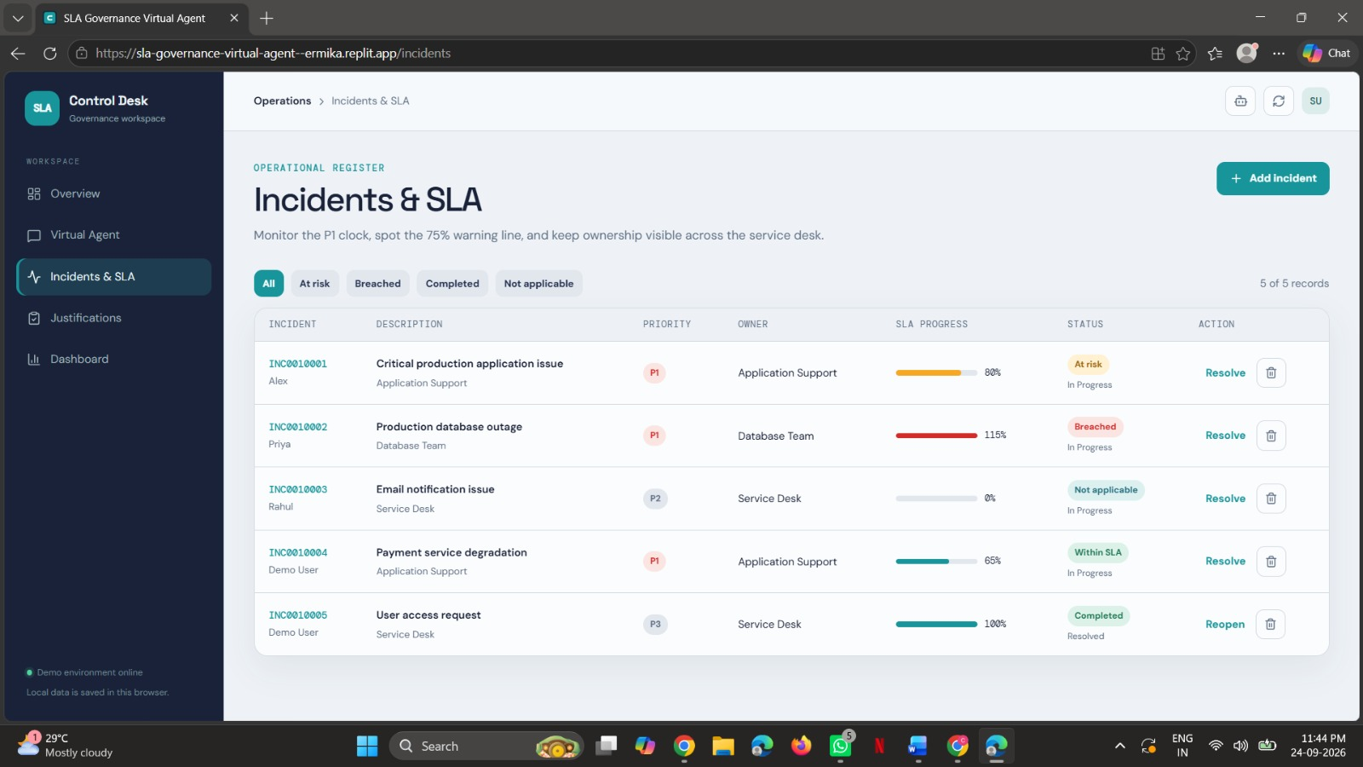

Figure 4: Breach Justifications
The Breach Justification module is used to document and manage explanations for SLA breaches. When an SLA is breached, the user selects the affected incident and specifies the reason for the breach. A detailed explanation can then be submitted, including the cause, impact, and recovery or preventive action. The Review Guidance section helps users provide consistent and meaningful justifications. Submitted records are maintained as an accountability trail so that managers can review the reason and supporting information associated with each SLA breach.
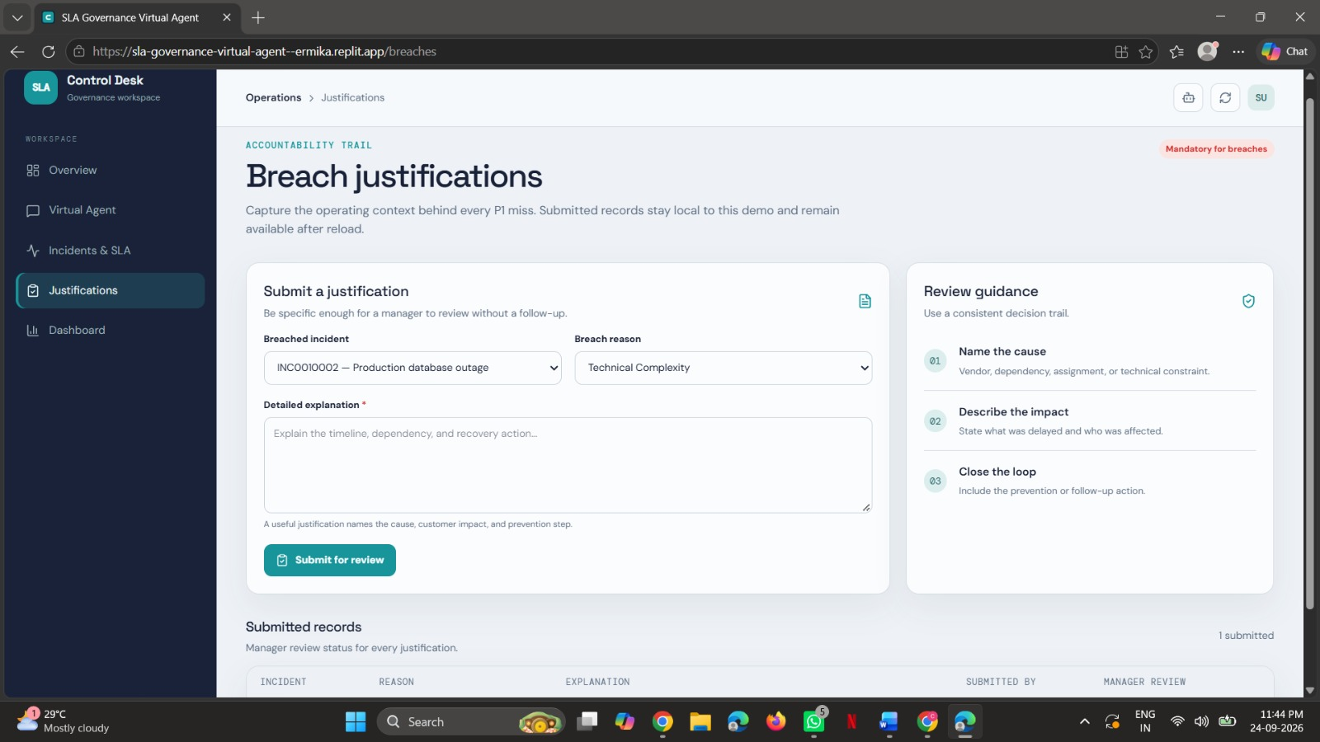
Figure 5.4: SLA Breach Justification Module

Figure 5: SLA Governance Dashboard
The SLA Governance Dashboard provides a centralized view of the current SLA performance and governance status of incidents. It displays important metrics such as completed incidents, incidents that are at risk, breached SLAs, and submitted breach justifications. The dashboard also provides a summary of breach reasons and identifies the teams where SLA breaches are concentrated. The policy summary section displays the configured P1 SLA target, warning threshold, and resolution status. The governance process at the bottom represents the complete workflow from incident creation and monitoring to warning, breach, justification, and review
The SLA Governance Dashboard provides a centralized view of the overall SLA performance and incident management activities. It displays important metrics such as completed incidents, at-risk incidents, breached incidents, and submitted justifications. The dashboard helps service desk managers quickly identify incidents that require immediate attention and monitor the progress of active SLAs. It also presents breach reasons and the teams associated with breached incidents, making it easier to identify areas requiring corrective action. The policy summary displays important governance rules such as the P1 SLA target and the warning threshold. The governance process section visually represents the complete flow from incident creation and monitoring to warning, breach, justification, and review. Overall, the dashboard improves visibility, accountability, and timely decision-making in SLA management.
Figure 5.5: SLA Governance Dashboard

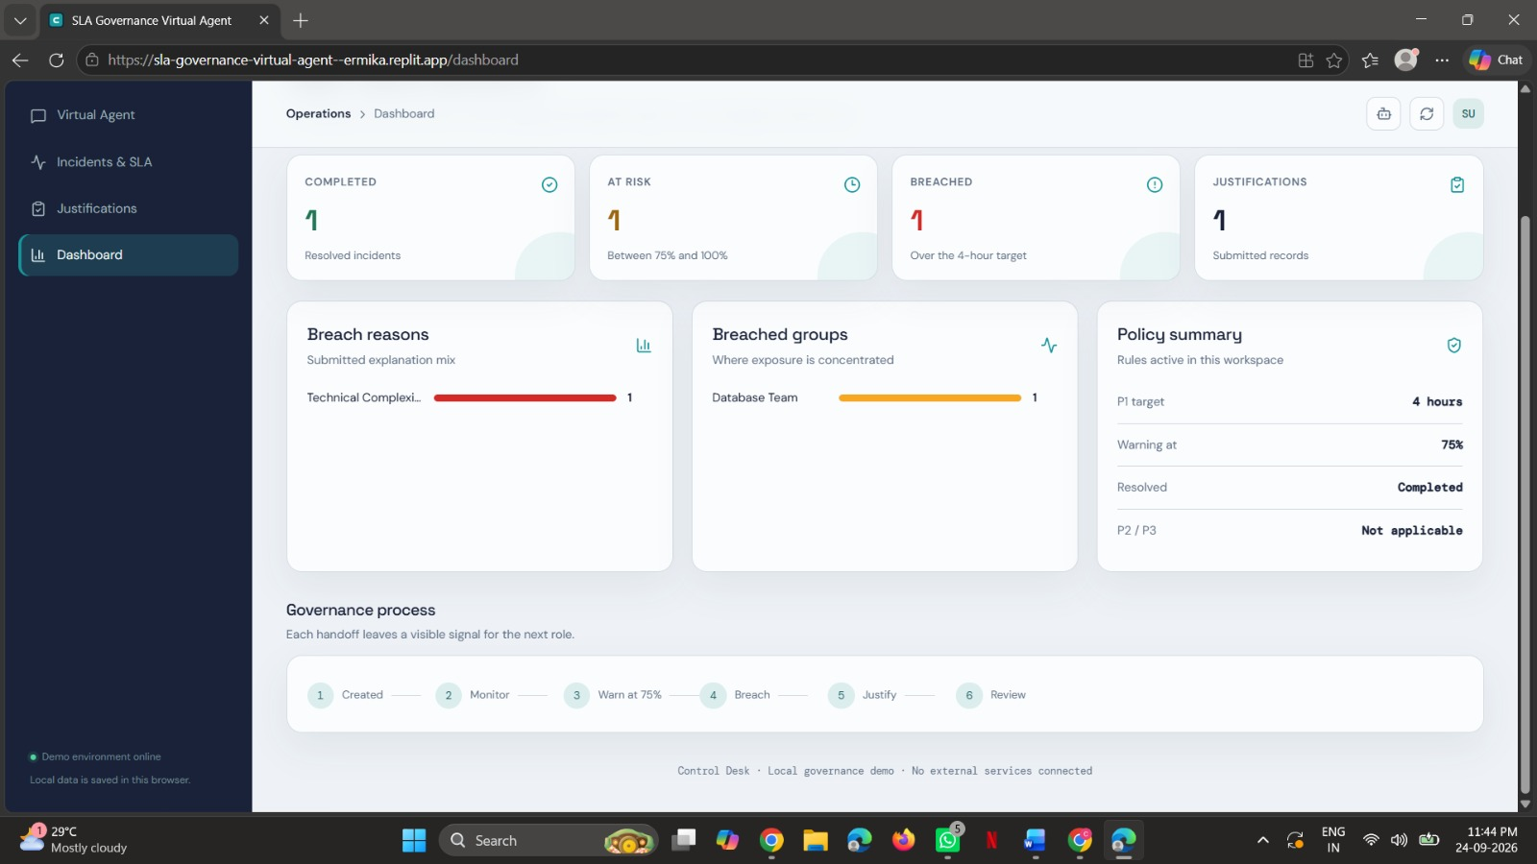

Feature | Result
Incident Registration | Incidents successfully added and maintained in the SLA register.
SLA Monitoring | Incident SLA progress continuously monitored based on priority.
At-Risk Detection | Incidents crossing the 75% threshold identified as at-risk.
Breach Detection | SLA breaches automatically identified when the target is exceeded.
Incident Management | Incident status, priority, owner, and SLA progress displayed.
Breach Justification | Mandatory justification submitted for breached incidents.
Virtual Agent | AI-based assistant provides SLA status and governance guidance.
Dashboard | Centralized dashboard displays SLA metrics and governance status.
Governance Workflow | Complete workflow from monitoring to breach review implemented.
Policy Management | P1 SLA target and warning threshold configured for governance.
5.2 Features and Results Implemented

The developed SLA Governance system integrates incident monitoring, SLA tracking, breach detection, and governance controls into a centralized application. Incident information is processed to determine the current SLA progress and identify whether an incident is within SLA, at risk, or breached. The system also maintains breach justification records and provides a Virtual Agent for assisting users with common SLA-related queries. The dashboard presents real-time governance information, helping service desk managers monitor incidents and take appropriate action. The project can also be extended with ServiceNow cloud services and enterprise service management platforms for scalable deployment and improved accessibility.
5.3 Conclusion
The SLA Governance Virtual Agent demonstrates how automation and intelligent assistance can be used to support effective Service Level Agreement management. By monitoring incident priority, SLA progress, ownership, and status, the system identifies incidents that require attention and provides appropriate governance actions.
The project successfully demonstrates the complete SLA governance lifecycle, including incident registration, SLA monitoring, at-risk identification, breach detection, breach justification, review, dashboard reporting, and Virtual Agent assistance.
The implementation of automated SLA monitoring and governance controls provides an opportunity to identify potential breaches before they become critical and maintain proper accountability when an SLA breach occurs.
The developed application provides a simple and user-friendly interface where service desk managers can monitor incidents, view SLA status, submit breach justifications, and obtain guidance through the Virtual Agent. This demonstrates how an automated governance solution can be transformed into a practical service management application.
Major Benefits
• Automated SLA monitoring reduces manual tracking of incident deadlines.
• Early risk identification helps detect incidents approaching SLA limits.
• Breach tracking provides clear visibility into SLA violations.
• Mandatory justification improves accountability and documentation.
• Virtual Agent assistance provides quick answers to common SLA queries.
• Centralized dashboard provides a clear view of SLA performance and governance status.
5.4 Future Scope
Real-Time ServiceNow Integration: Integrate the application with ServiceNow to automatically retrieve live incident and SLA information.
Automated Notifications: Implement email or notification alerts when incidents approach the SLA warning threshold or become breached.
Advanced Analytics: Use historical SLA data to identify recurring breach patterns and generate governance reports.
Role-Based Access: Introduce administrator, manager, and service desk roles with appropriate permissions for different operations.
5.5 Final Conclusion
The SLA Governance Virtual Agent successfully demonstrates the application of automation, SLA monitoring, and intelligent assistance for effective service management. The project provided practical experience in incident management, SLA tracking, breach detection, governance workflows, dashboard development, and Virtual Agent implementation.
The system provides a strong foundation for developing advanced SLA governance and service management applications. With future enhancements such as real-time ServiceNow integration, automated notifications, advanced analytics, role-based access, and predictive SLA monitoring, the solution can be extended into a comprehensive enterprise SLA governance platform.

CHAPTER-6
VERIFIABLE CREDENTIALS

CHAPTER-6
VERIFIABLE CREDENTIALS
Verifiable link for certificate
https://myskillwallet.ai/certificate/6a0d4a652526f30f2d1d3c0b/6a180f02a4747a8e36f126ec
GitHub Repository Link
http://github.com/poojitha-9933/Virtual-AgentDriven-SLA-Breach-Awareness-Justification-System/tree/main
QR CODE:

